Brain Tasks App DevOps Documentation
This document provides end-to-end DevOps guidance for the Brain Tasks App, a web application built with the Vite toolchain. It is aimed at DevOps engineers and covers building, containerization, CI/CD, deployment to Kubernetes, and monitoring. All sensitive values (AWS IDs, secrets, etc.) are redacted or masked.

Overview
The Brain Tasks App is a single-page web application built with Vite as the build tool. In development, source files (HTML/CSS/JS or a framework like React/Vue) are served by Vite’s dev server. For production, running npm run build (with Vite) generates optimized static files in the dist/ directory[1]. These assets include an index.html and hashed CSS/JS under dist/assets/ (content-hashed for cache-busting)[2]. The built files can be served by any static file server. In this project, the static site is ultimately served by NGINX in a Docker container.
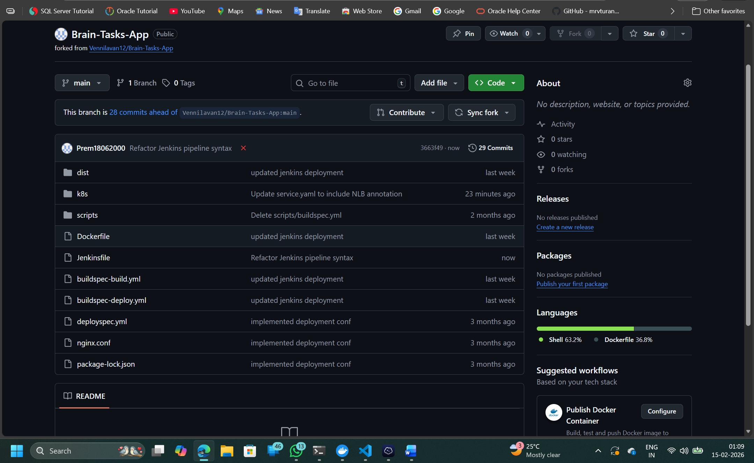

Build Process
To build the app for production, use the NPM script defined in package.json. Typically this is:
npm install # install dependencies
npm run build # runs `vite build`
Running npm run build invokes Vite’s build process and outputs the production-ready site to dist. The output folder contains index.html and static assets (JS/CSS/images) with hashed filenames for cache control. For example, Vite’s static asset handling ensures referenced assets get hashed names in the production build[2]. You can verify the build locally with:
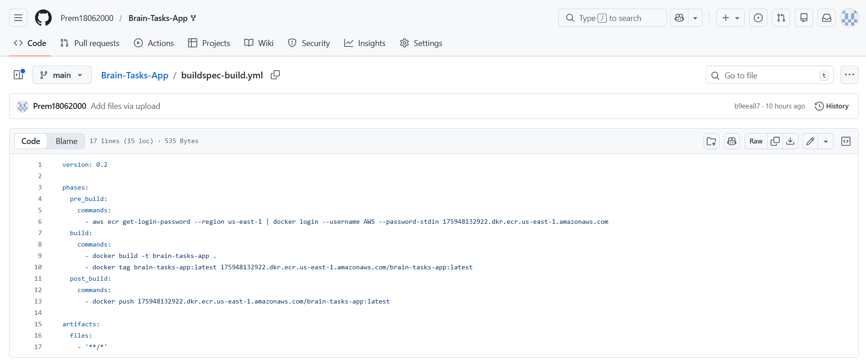

Dockerization
For deployment, the app is containerized using a multi-stage Docker build. The Dockerfile typically has two stages:
- Builder stage (Node): Uses a Node image to install dependencies and run the Vite build.
- Runner stage (NGINX): Uses an NGINX image to serve the built files.

FROM node:alpine AS builder
WORKDIR /app
COPY package*.json ./
RUN npm ci
COPY . .
RUN npm run build
FROM nginx:alpine
COPY --from=builder /app/dist /usr/share/nginx/html
RUN rm /etc/nginx/conf.d/default.conf
COPY ./nginx.conf /etc/nginx/conf.d
EXPOSE 80
CMD ["nginx", "-g", "daemon off;"]
In this pattern, the first stage installs Node modules and builds the app. The second stage copies the dist/ folder into NGINX’s web root (/usr/share/nginx/html)[4]. An nginx.conf is provided (in the repo) to configure routing. Typically, the NGINX config listens on port 80 (mapped to the container), serves static files, and includes a try_files $uri /index.html; rule so that all routes fall back to index.html (necessary for client-side routing in SPAs)[5]. Finally, the Dockerfile exposes port 80. The result is a lightweight web server container that delivers the static app.

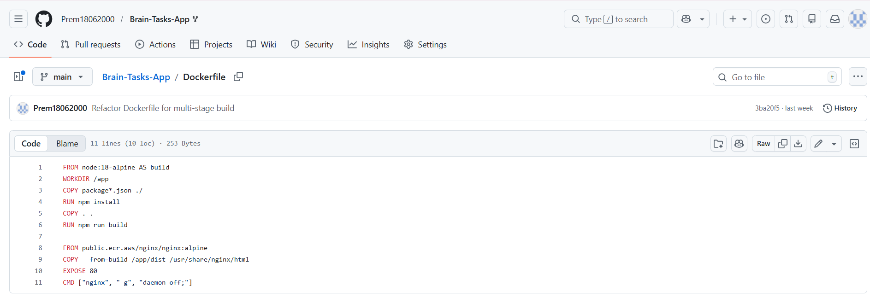

CI/CD Pipeline
Continuous integration and deployment are automated. This project supports both Jenkins-based and AWS CodePipeline-based workflows, as hinted by the presence of a Jenkinsfile and AWS buildspec files.
- AWS CodeBuild / CodePipeline: The repo includes buildspec-build.yml and buildspec-deploy.yml. In AWS CodePipeline, the Build stage can use CodeBuild with buildspec-build.yml, and the Deploy stage can use CodeBuild (or CodeDeploy) with buildspec-deploy.yml[6]. A buildspec is a YAML file that specifies build commands, environment variables, and artifacts for CodeBuild[7]. For example, in a similar AWS pipeline setup the repo shows:
- ├── buildspec-build.yml # CodeBuild (Build stage)
├── buildspec-deploy.yml # CodeBuild (Deploy stage)
- which separates the build and deploy logic[6]. In the buildspec, typical phases include installing dependencies, running tests, building the Docker image, and pushing to a registry. The deploy buildspec might run kubectl commands to apply manifests to EKS.
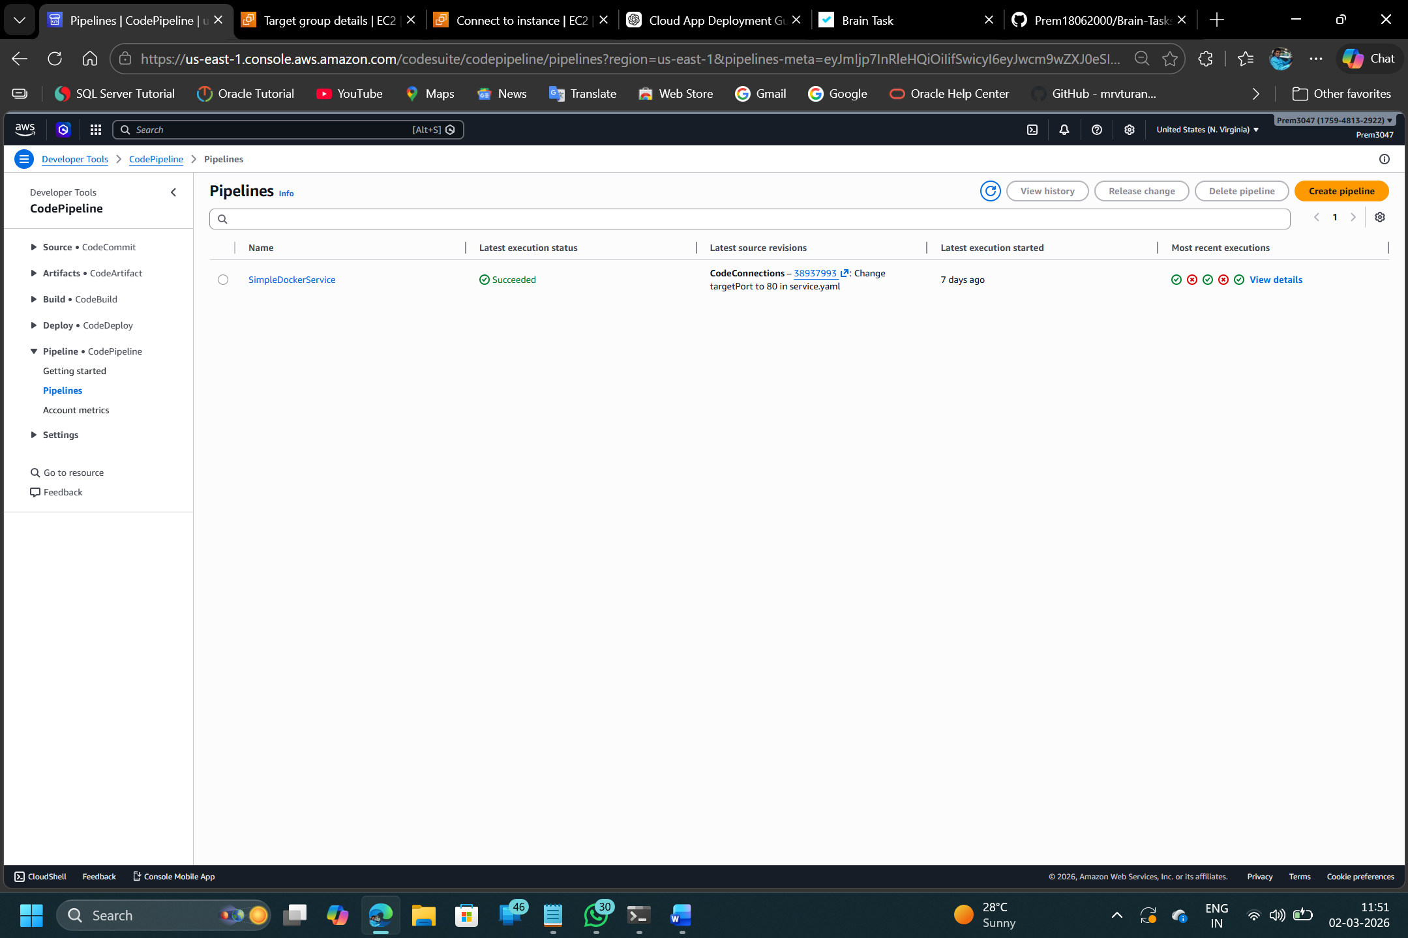

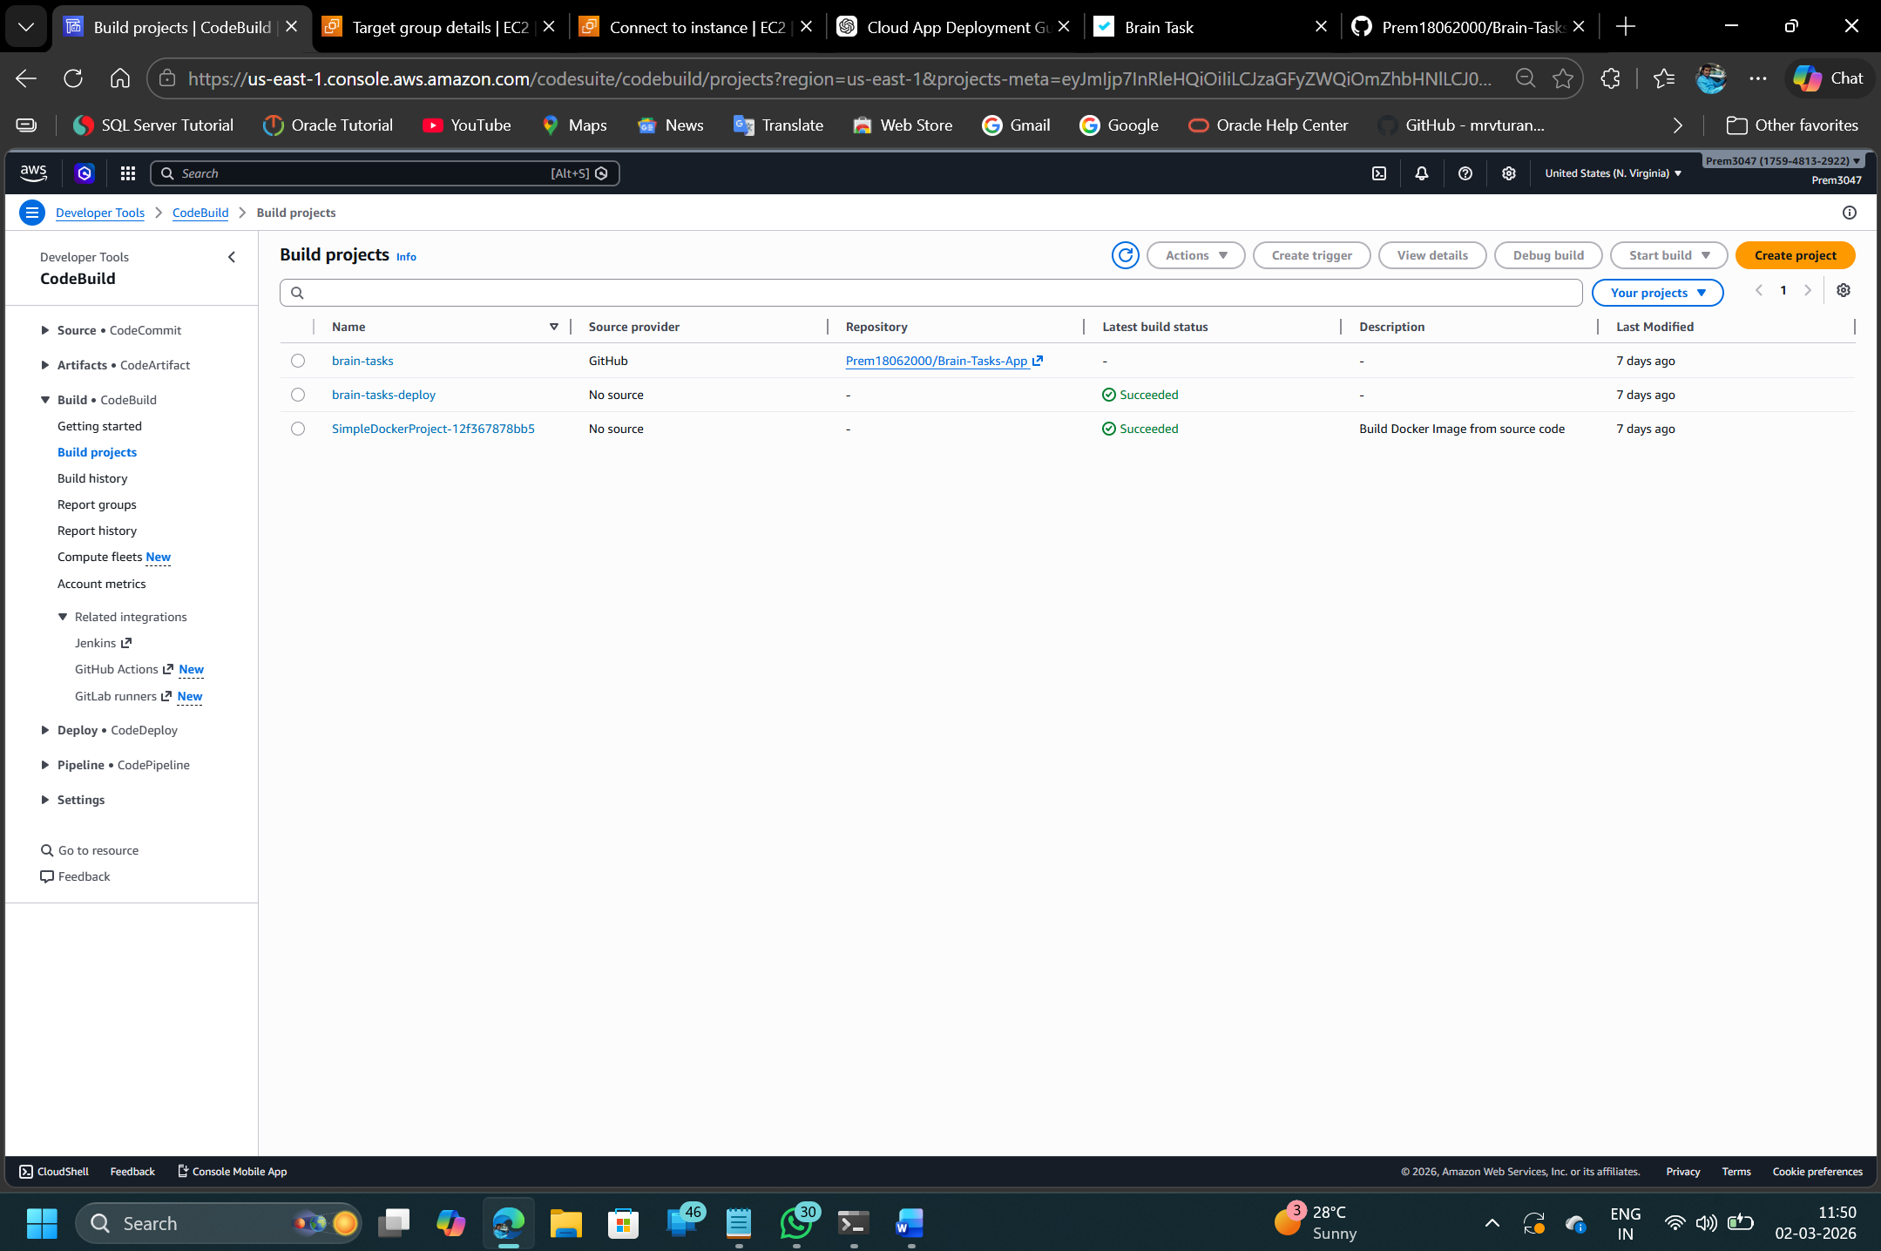
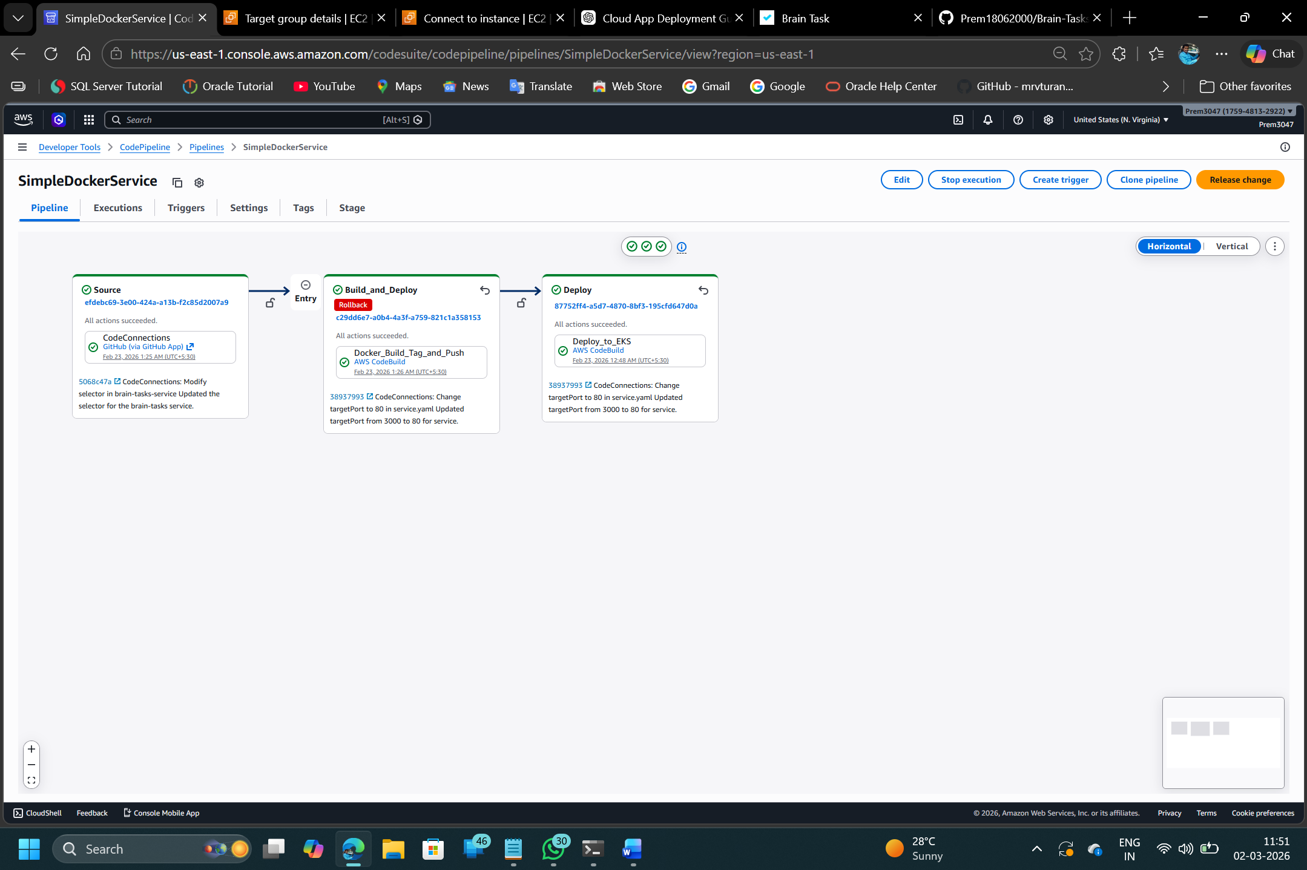

Kubernetes Deployment
The application is deployed to Kubernetes (Amazon EKS). Under k8s/app, there are two key manifests:
- deployment.yaml: Defines a Kubernetes Deployment object (apiVersion: apps/v1). This specifies the container image (from ECR), number of replicas, and pod template. A Deployment “manages a set of Pods to run an application workload” in a declarative way[10]. For example, if it sets replicas: 3, Kubernetes ensures three pods are running the given container image. Updating the image or other spec fields triggers a rolling update.
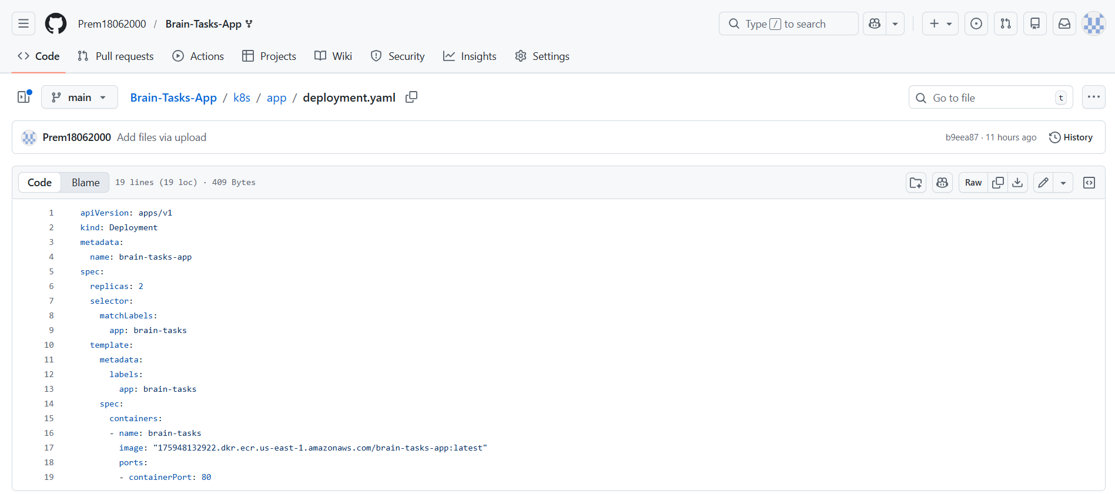
- service.yaml: Defines a Service that exposes the app. In AWS, this is typically type LoadBalancer, which provisions an ELB to expose the app externally. As one pipeline description confirms, the app is “Exposed via LoadBalancer (port 3000)”. Thus the Service maps port 3000 of the pods to a public endpoint. After deployment, navigating to the LoadBalancer’s DNS will serve the app on port 3000 .
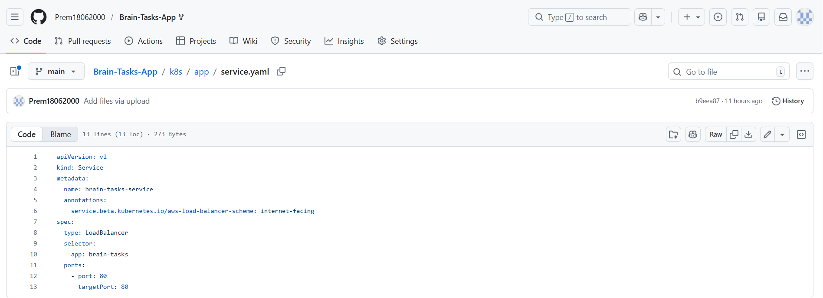

To deploy, the CI/CD pipeline (whether Jenkins or CodeBuild) applies these manifests. For example:
kubectl apply -f k8s/app/deployment.yaml
kubectl apply -f k8s/app/service.yaml
Kubernetes will then pull the image from ECR and start the pods. Because the Service is a LoadBalancer, you can access the app at the allocated public IP (e.g. http://<ELB-DNS>:3000).
Additional Kubernetes notes: - Ensure kubectl is configured with the EKS cluster’s context (via AWS IAM auth). The Jenkins/CodeBuild agent must have permissions (eks:DescribeCluster, IAM role or assume-role for EKS access). - Rollbacks can be managed by rolling back the Deployment if needed (Kubernetes tracks revisions).

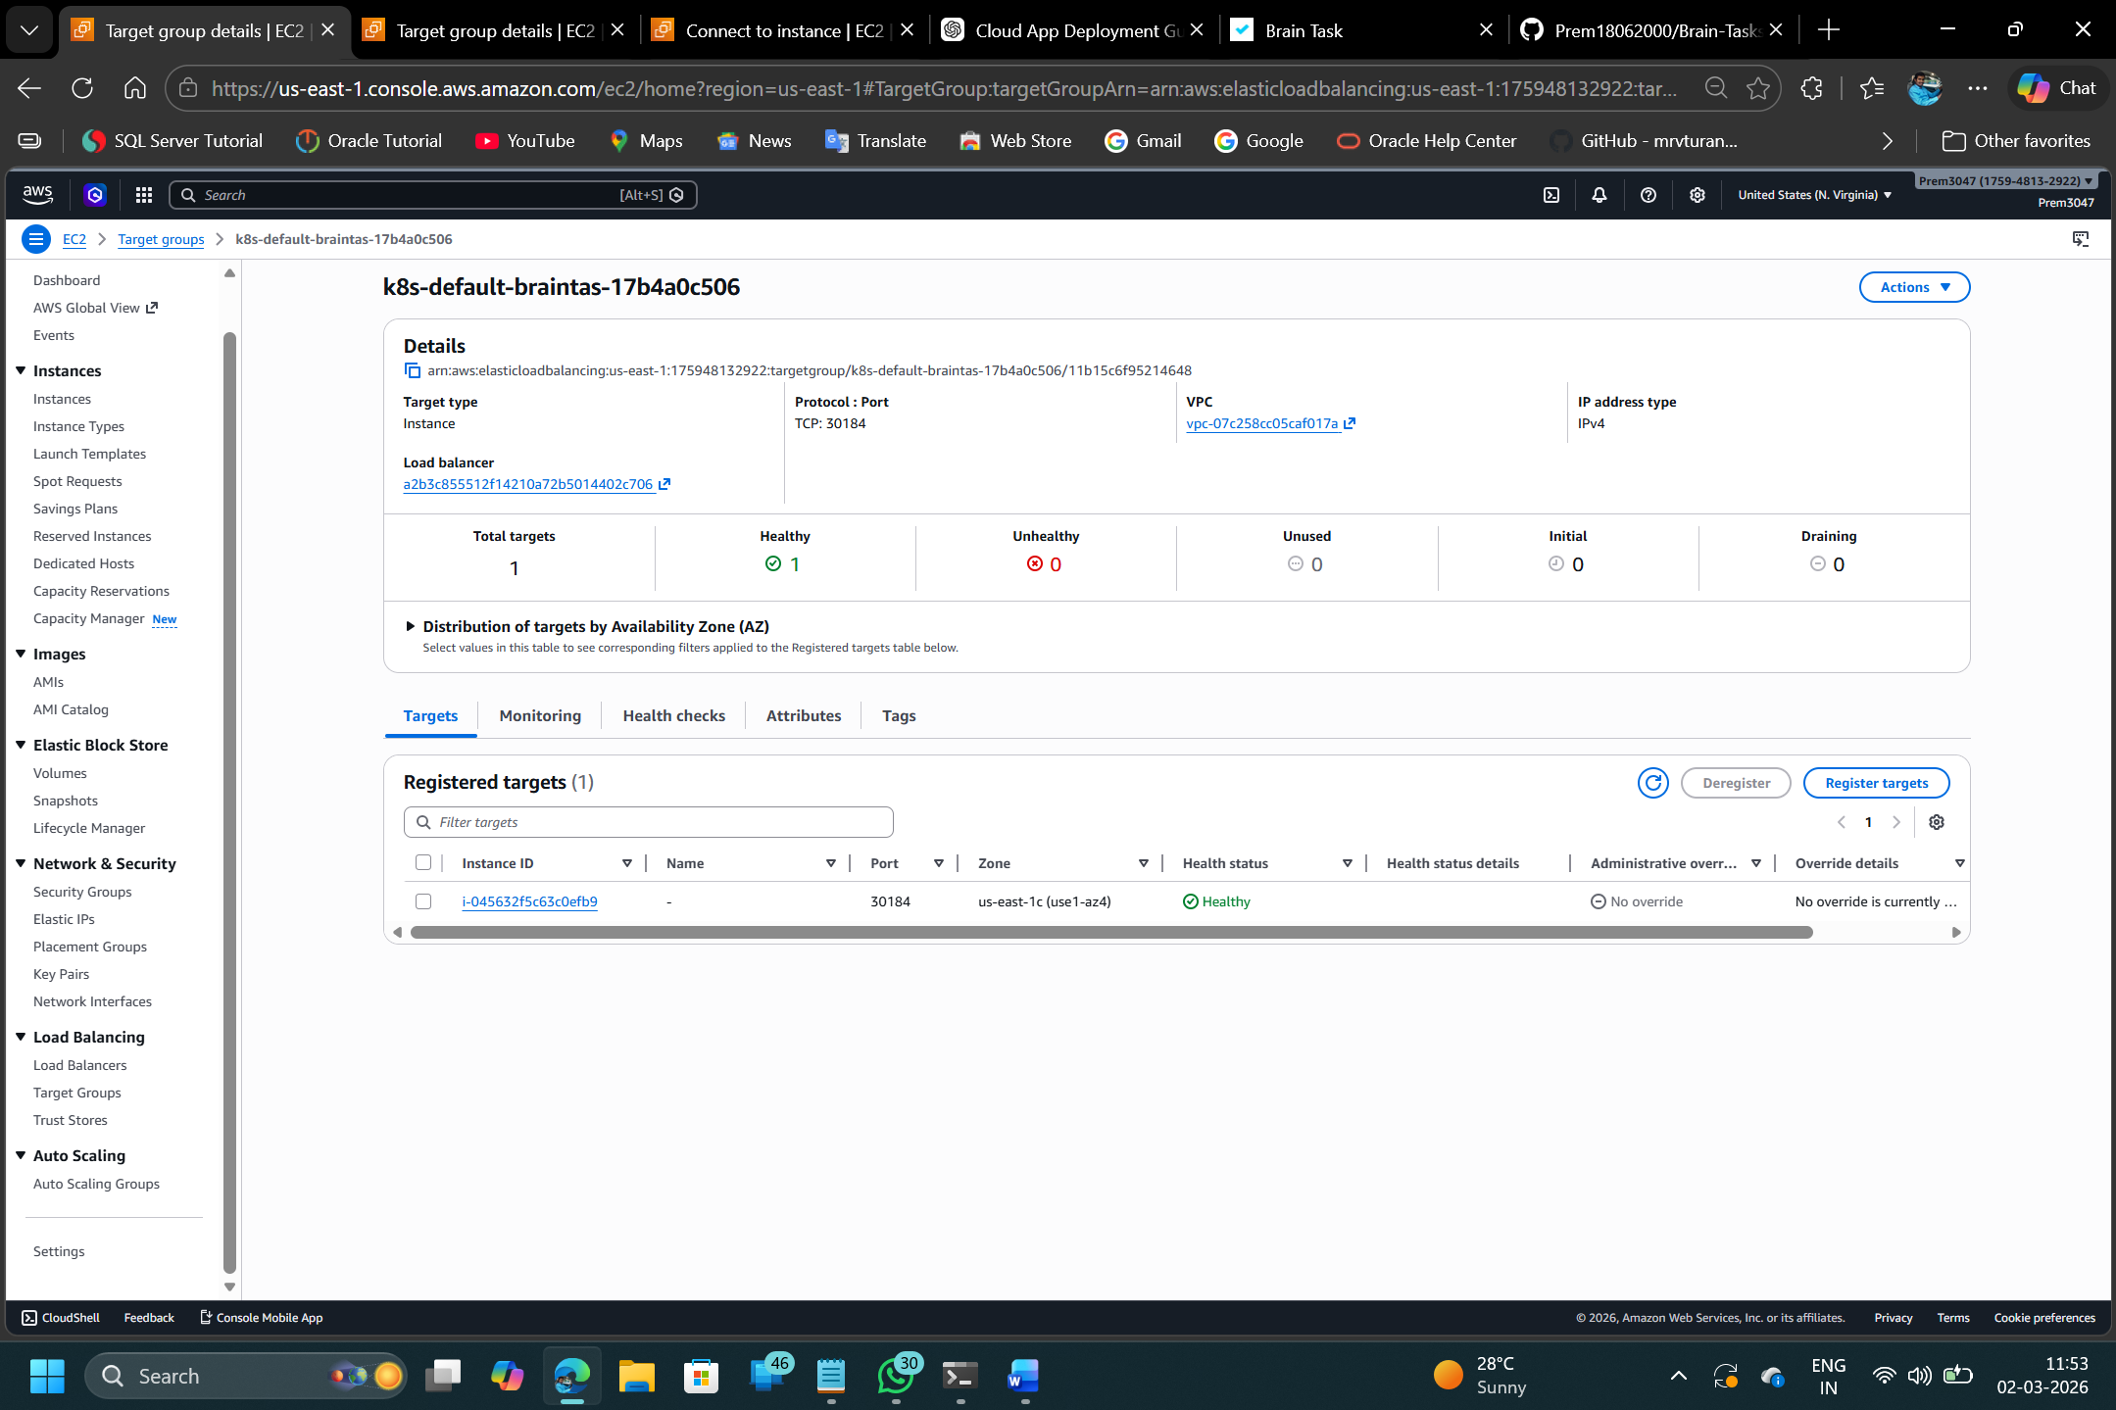

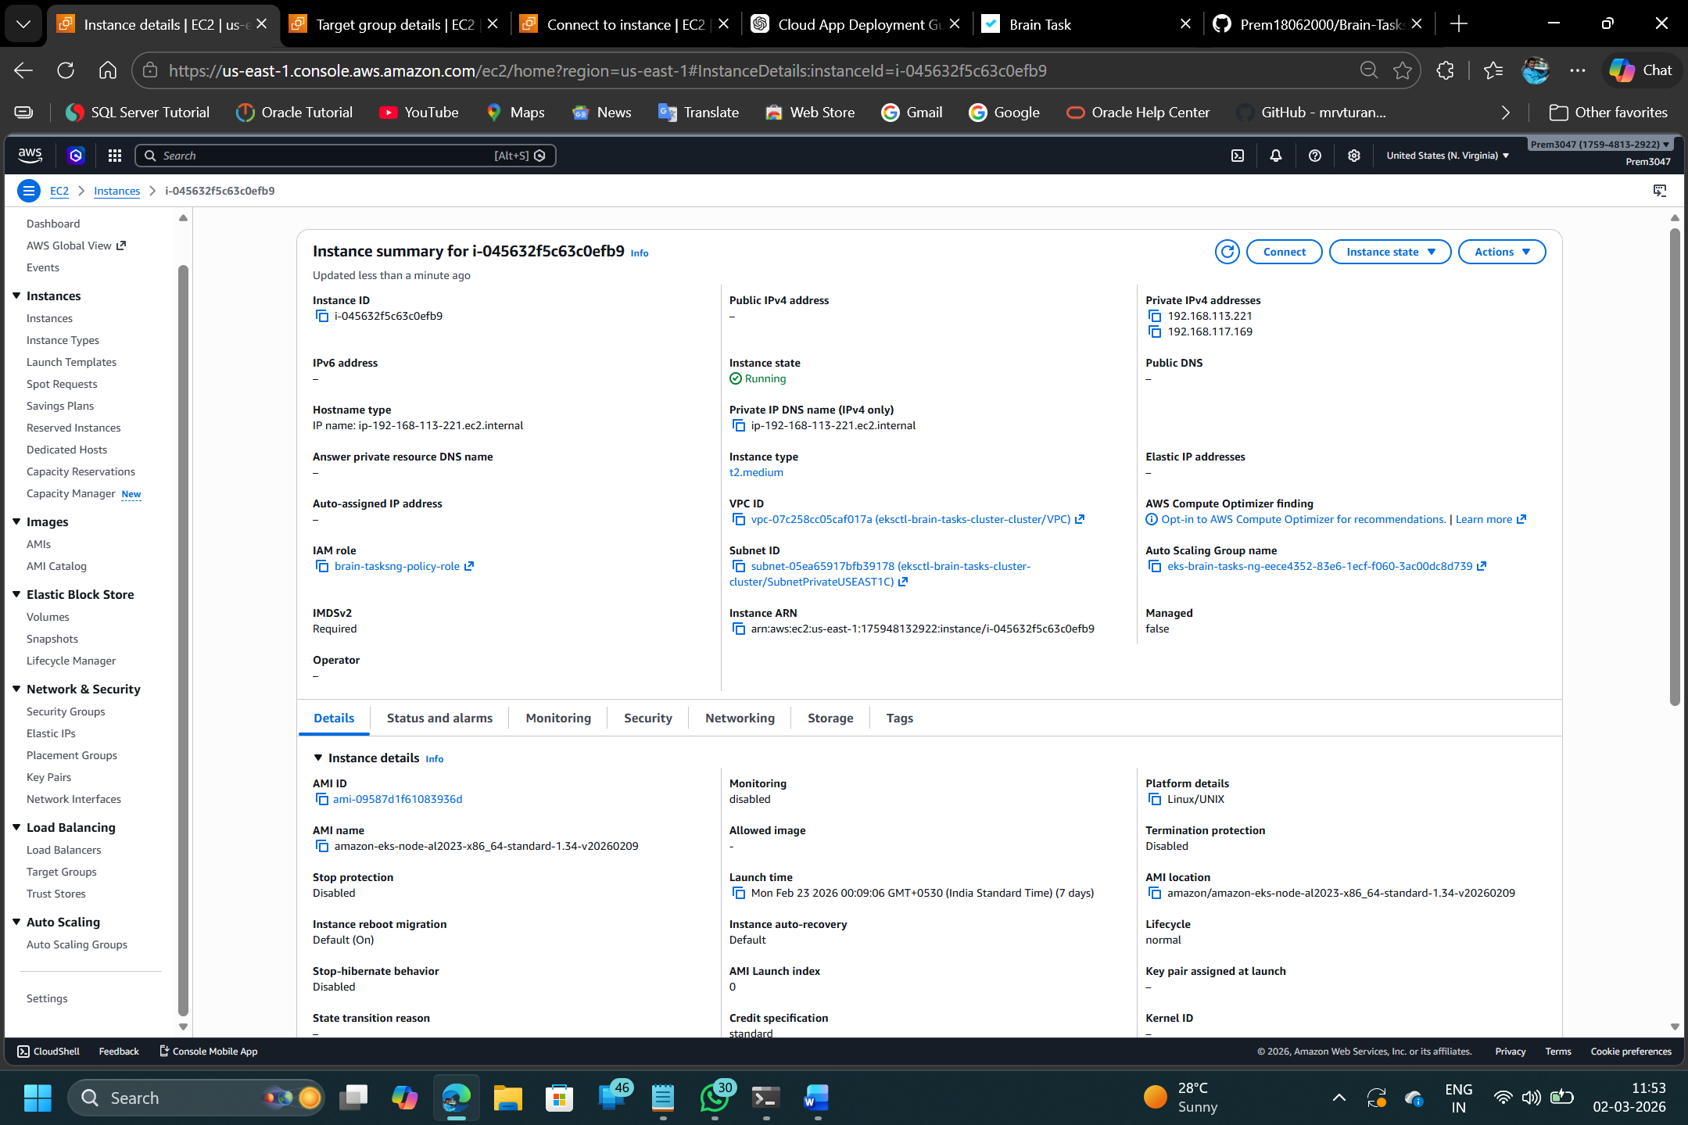

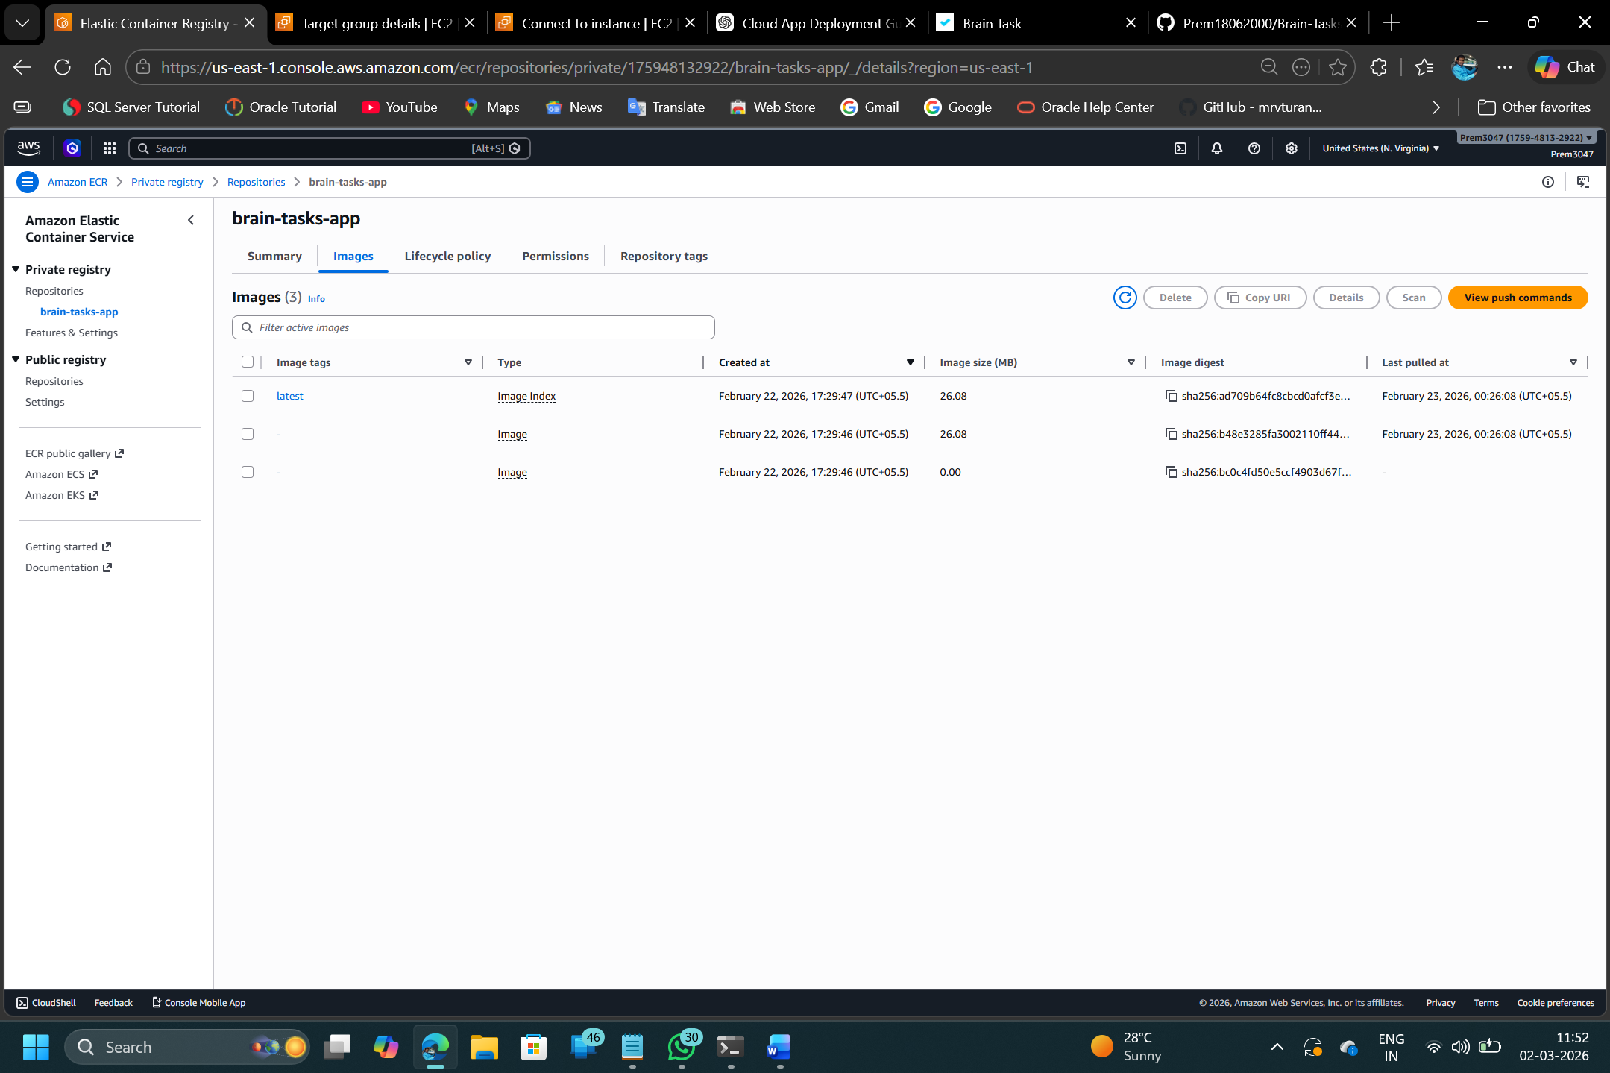

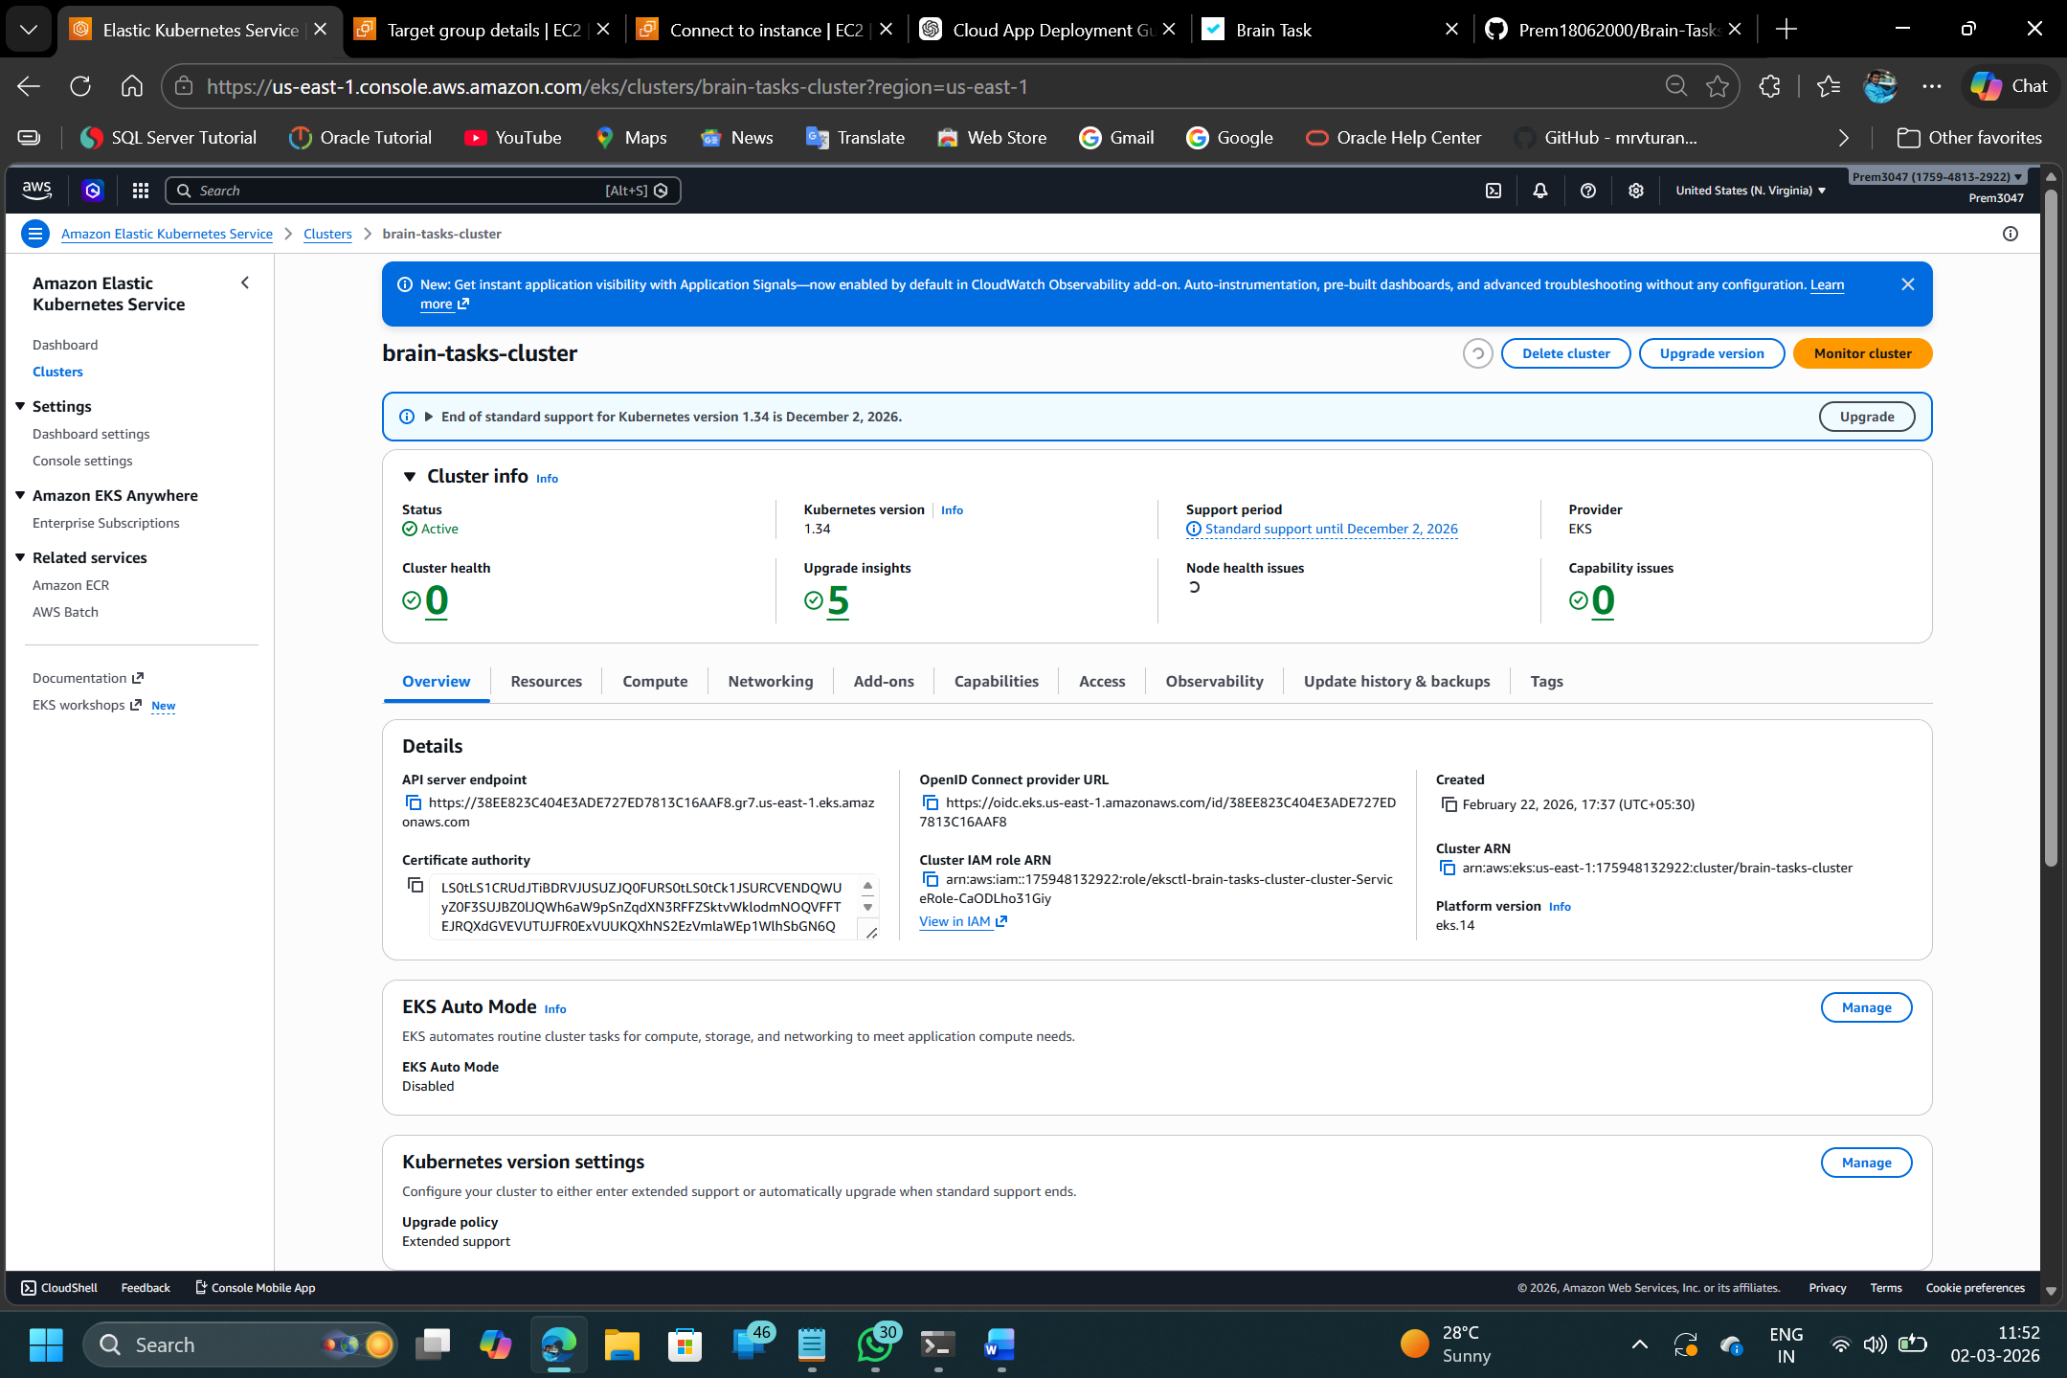

Monitoring and Service
Amazon CloudWatch is a monitoring and observability service provided by Amazon Web Services (AWS) that enables real-time tracking of cloud resources, applications, and infrastructure. It collects performance metrics, log files, and event data from various AWS services such as Amazon EC2, AWS Lambda, and Amazon RDS. These metrics include CPU utilization, memory usage, network traffic, and disk operations, allowing administrators to continuously monitor system performance and health. CloudWatch provides customizable dashboards that visually represent key performance indicators, helping teams gain better operational visibility.
In addition to monitoring, CloudWatch supports centralized log management through CloudWatch Logs, enabling efficient troubleshooting and performance analysis. It allows users to configure alarms based on predefined thresholds, which can automatically trigger notifications or actions such as resource scaling and automated responses. By integrating with multiple AWS services, CloudWatch ensures proactive issue detection, improved reliability, optimized resource utilization, and enhanced overall system performance.
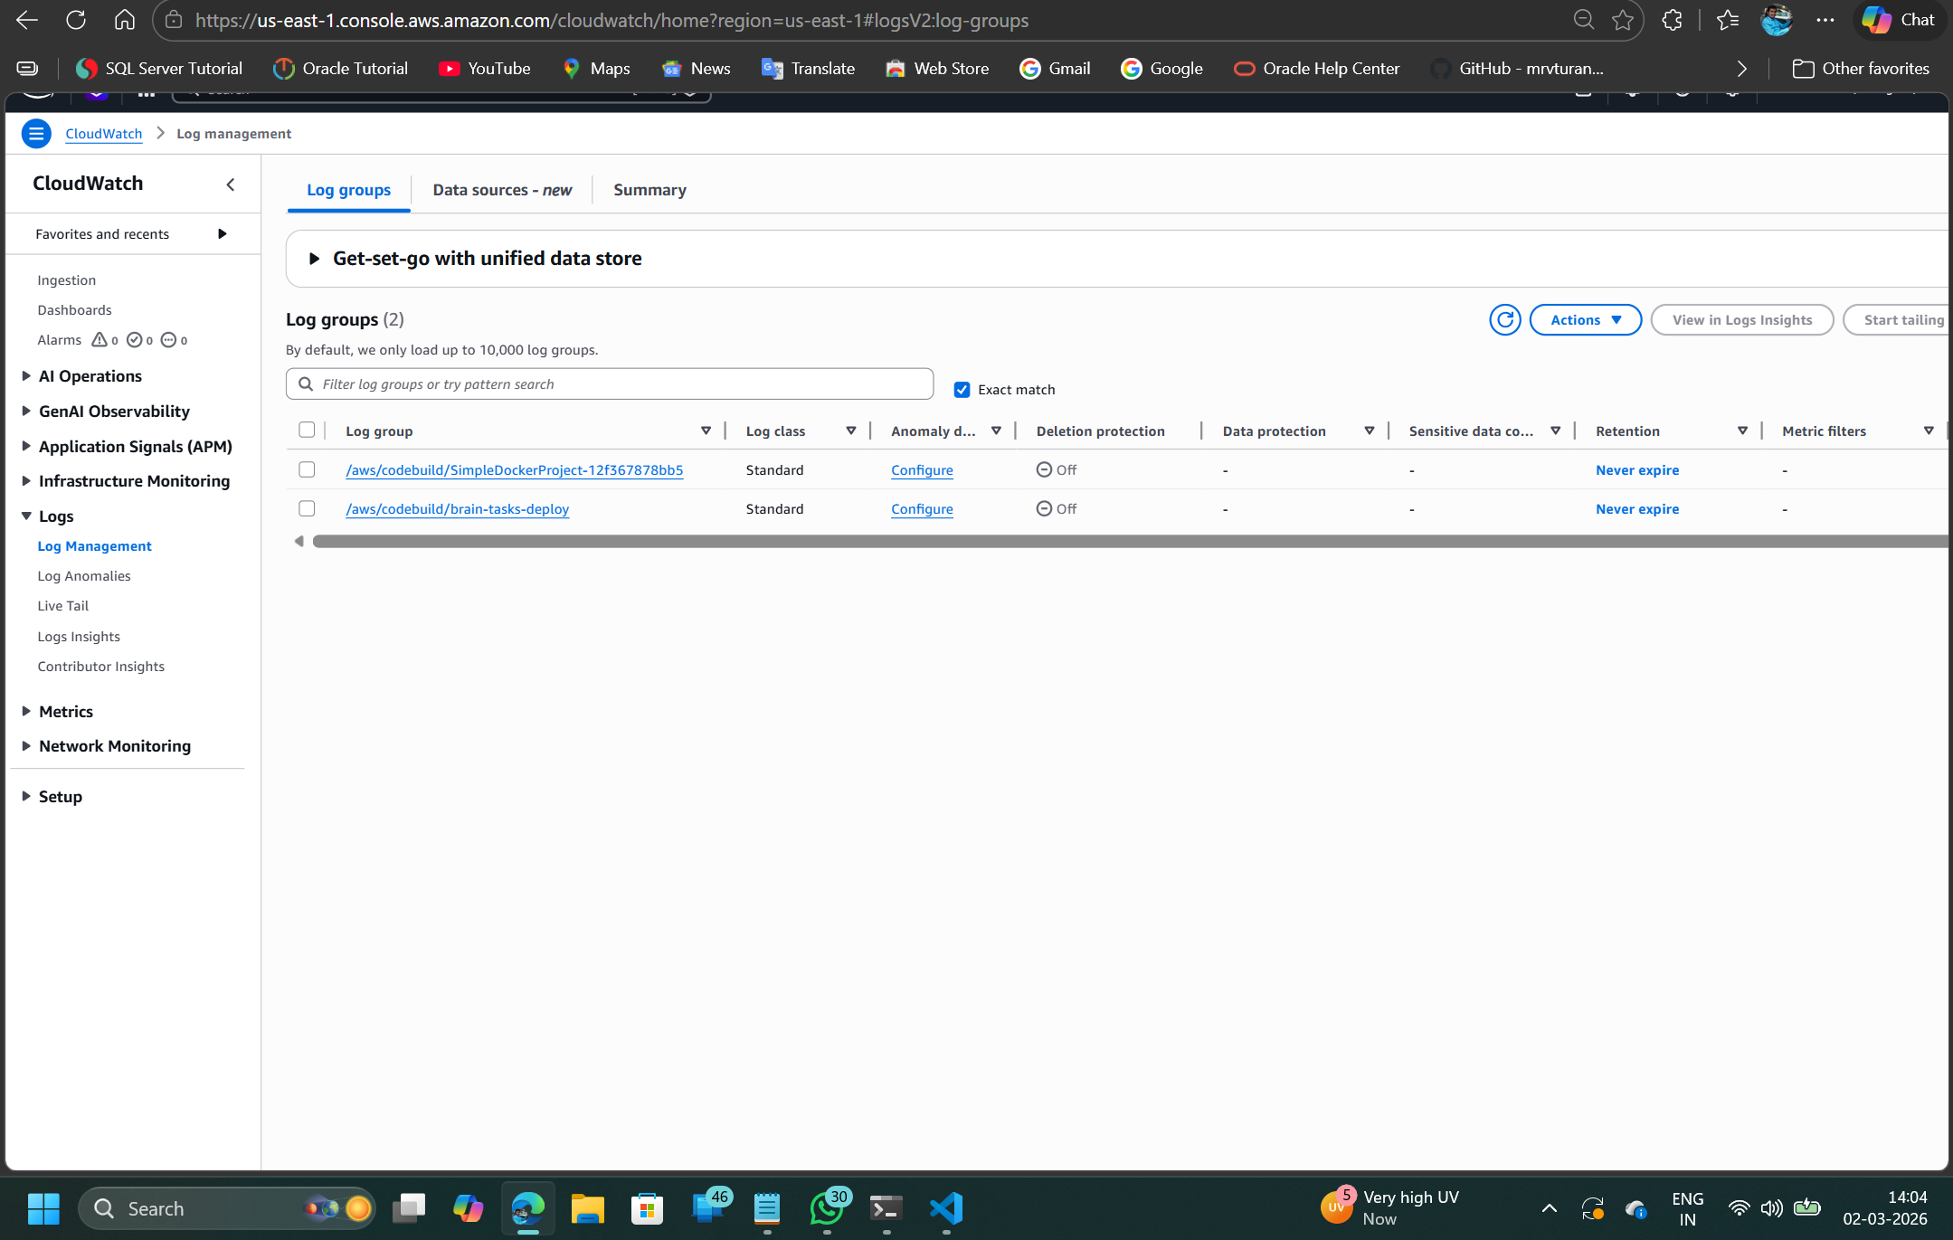

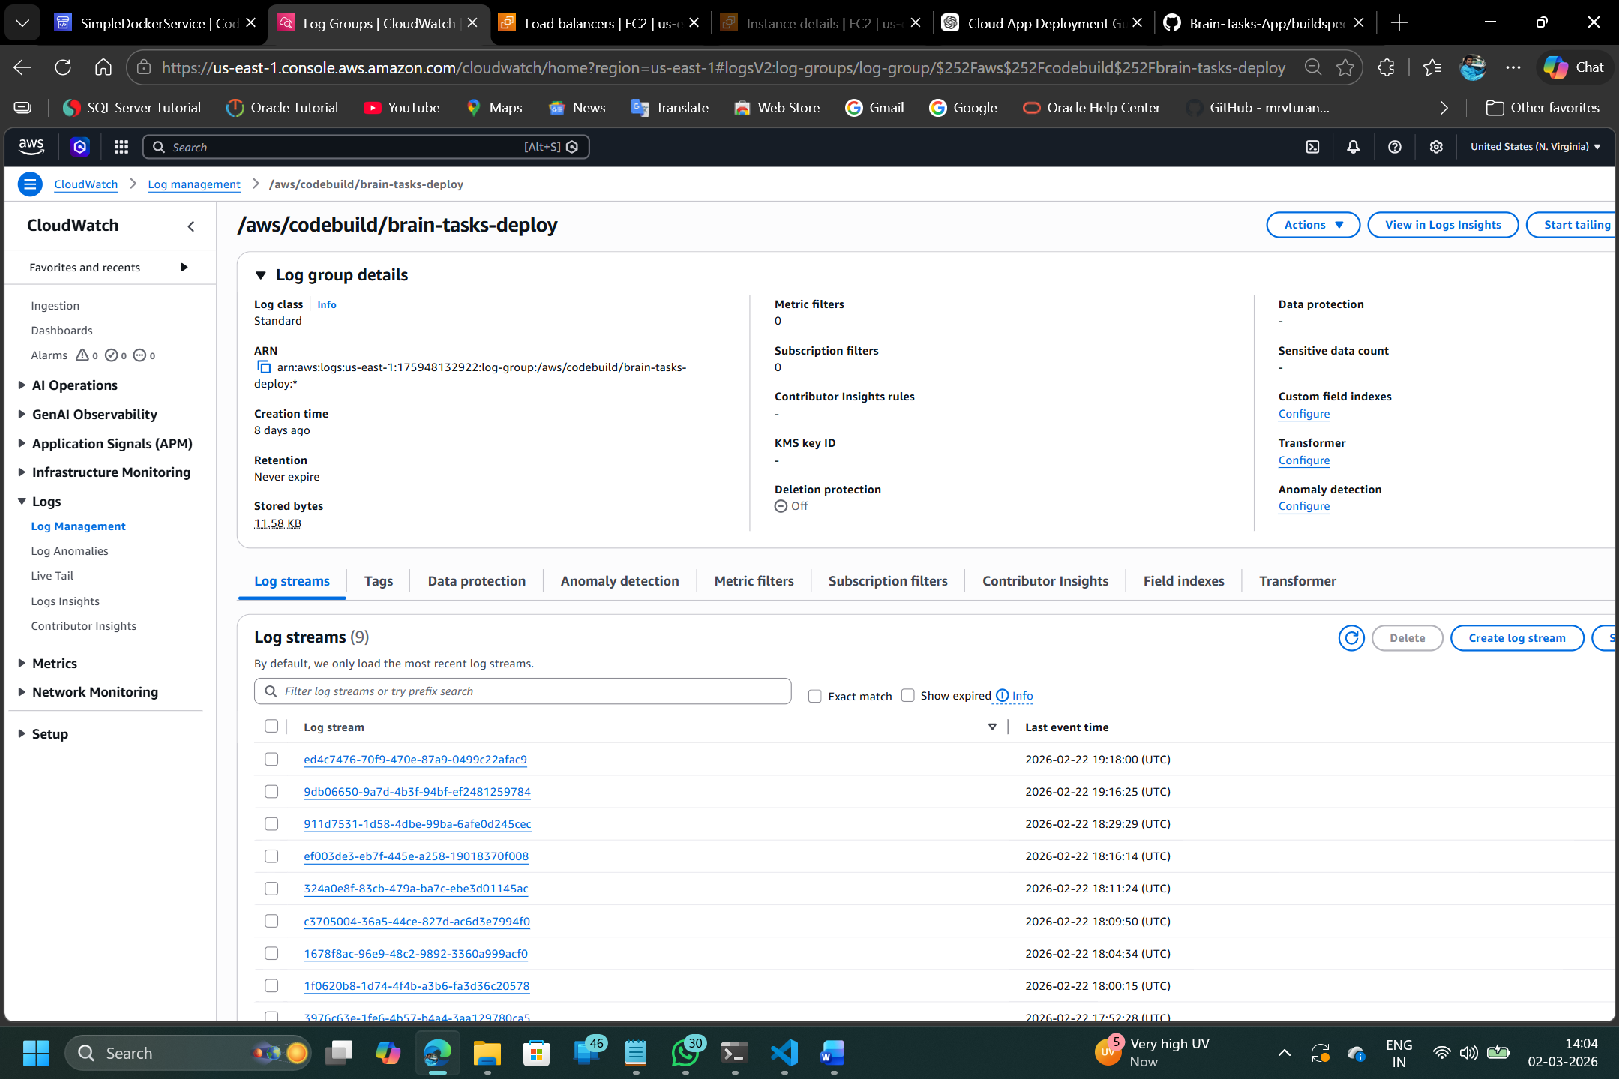

Output

